Geophysics 325 Final exam

Instructor Dr. Martyn Unsworth
Date Thursday December 13th 2001
Time allowed 9:00 a.m. - noon

Please attempt all three questions.

Notes and books may not be used during the exam.

Calculators are permitted.

Please show all working, as credit will be given for method as well as the final answer.

All questions should be directed to the invigilator.

Question 1 – Gravity exploration

- Gauss’s Theorem states that

^{S}∫g.dS = 4πGM

Explain what this theorem means in words. Then use it to derive a value of the acceleration of gravity (g_{r}) at a distance, r, from the centre of the Earth. Assume that the Earth has a uniform density ρ and radius R. Consider the case when r > R (6 points)

- Repeat part (a) for a point within the Earth (r < R) and sketch the variation of g_{r} as a function of r (0 to ∞)
(6 points)

- Several corrections must be applied to gravity data before it can be interpreted. Summarize the three main corrections (temporal and spatial) and explain their physical basis.

For each correction, include a figure or graph to illustrate your answer.
(12 points)

- What is the geoid? How can it’s location be mapped?
(4 points)

Total = 28 points

Question 2 - DC resistivity exploration

- Figure 1 shows two sets of layered Earth models. Sketch the apparent resistivity curves that would be measured with a Wenner array. Where possible, indicate specific values of apparent resistivity and a-spacings for the curves.
(14 points)

- A crystalline rock has an electrical resistivity of 10000 ohm-m and contains a brine with a resistivity of 0.1 ohm-m The rock contains 2% fluid by volume.

Consider a 1 m x 1 m x 1m cube of the saturated rock. Calculate the maximum and minimum resistivity values the saturated rock could exhibit. Explain your answers. (4 points)

For each case, sketch the distribution of brine within the rock. (4 points)

Explain the conduction mechanisms responsible for the differing resistivities of the rock and brine (4 points)

- Describe two common applications of DC resistivity exploration. For each explain the cause of the high/low resistivity values.
(8 points)

Total = 34 points

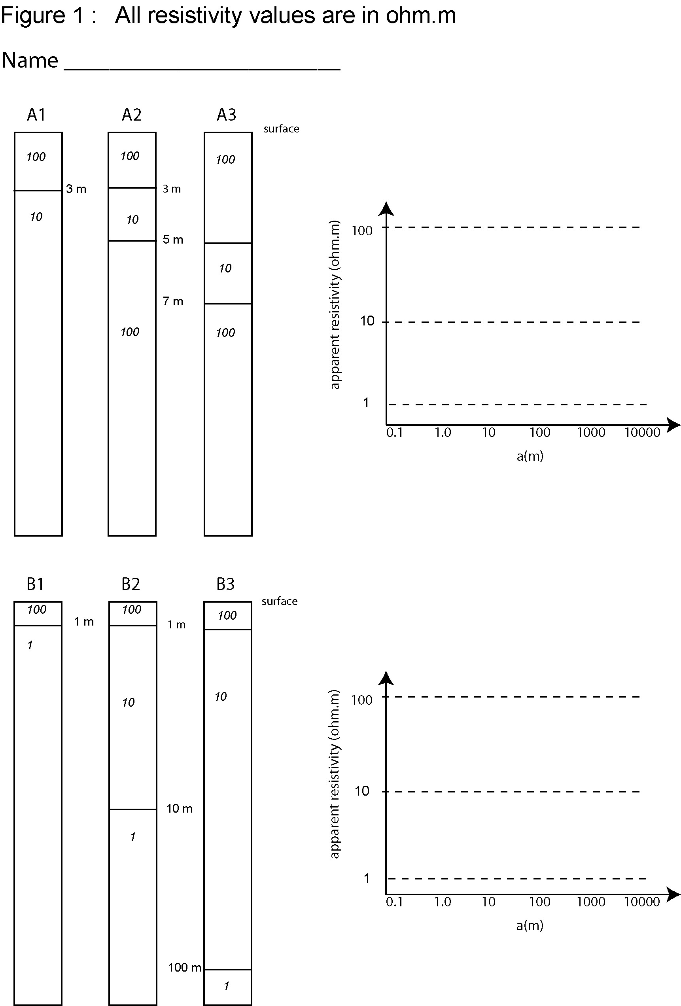

Question 3 - Magnetic exploration

- A vertical granite dike is located in Nunavut at the North magnetic pole where the Earth’s magnetic field, B=B_{E} . The dike has a high magnetic susceptibility and the host rock has a susceptibility, k =0. The base of the dike is at a great depth. The upper end of the dike is at a depth d acts as a monopole of strength m. The magnetic field of the monopole is given by

B_{r} = 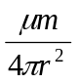

Magnetic measurements are made on a surface profile that crosses the dike at right angles. The dike is located at x=0. Show that the vertical component of the magnetic field measured across the dike is

Z = B_{E} + 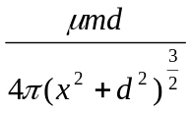

Sketch the vertical magnetic field anomaly on a profile that crosses the dike at right angles. You may ignore remnant magnetization. (6 points)

- Calculate an expression for the half-width of the vertical magnetic anomaly in terms of the depth of the top of the dike (d) (6 points)

- Figure 2 shows a series of cross-sections through in a region where the magnetic susceptibility varies. Sketch the variation of total magnetic field along this profile. Numerical values are not needed, but make the relative magnitude of the anomalies clear. (16 points)

- Describe two ways that a rock can acquire a permanent (remnant) magnetization.
(6 points)

- Describe three ways in which the Earth’s magnetic field varies with time. Briefly indicate the cause of these variations. For each indicate an approximate timescale. (9 points)

Total 38 points



