Geophysics 325

A1: What is geophysics?

- The study of the Earth using the basic principles of physics.

- Once pursued as an individual discipline, but now generally realized that geophysics is most effective when seen as integral part of the Earth Sciences

- Interpretation of geophysical data requires input from other branches of Earth science such as structural geology, geochemistry etc (and vice versa)

Geodynamics
How does the Earth work?

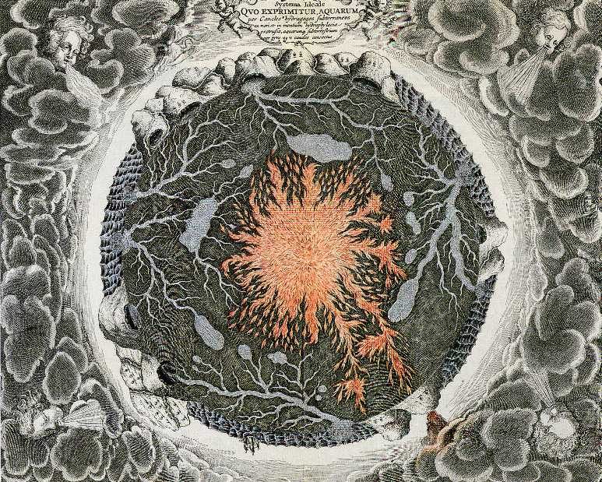
18th Century view of Earth’s interior

Exploration geophysics
How can we find out what is inside the Earth?

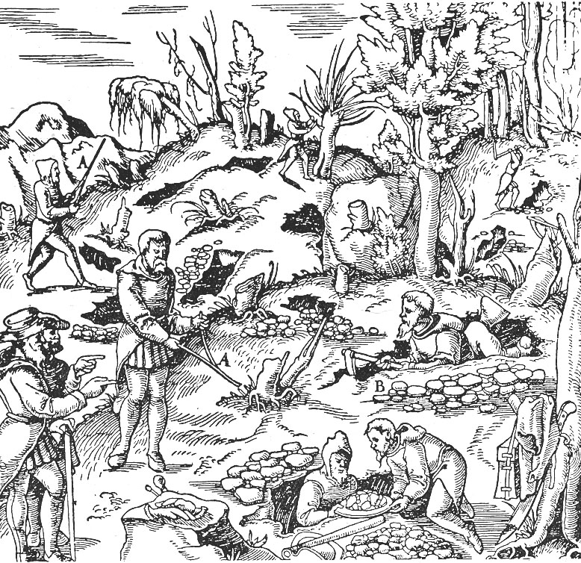

From De Rey Metallica, by Agricola,1580

325 A2 Basic structure of the Earth

A2.1 Radial structure

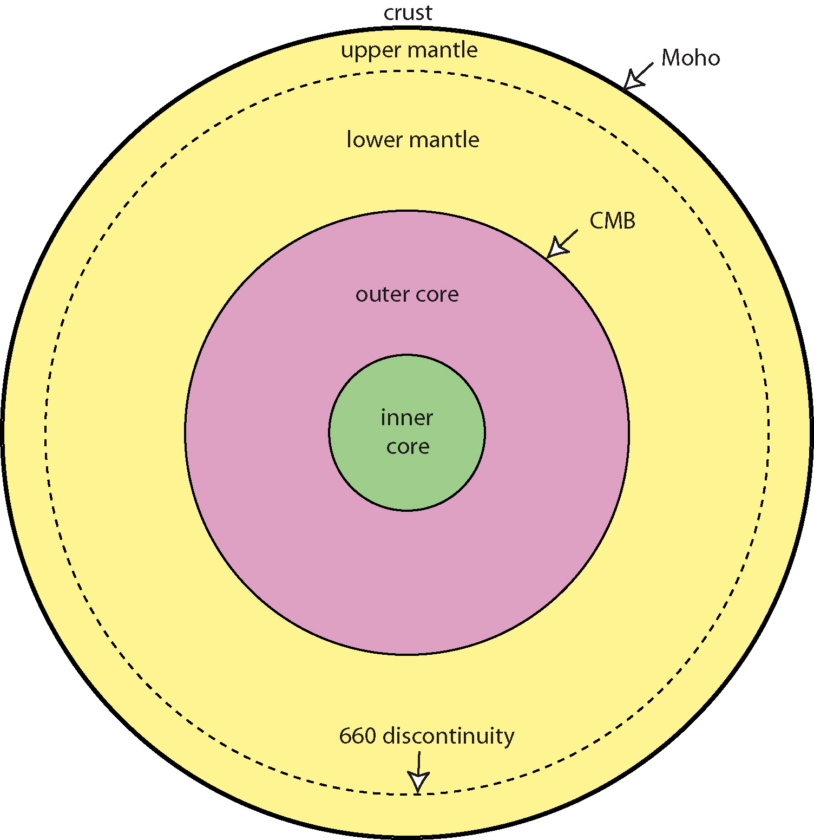

●The crust and mantle have distinct chemical compositions and are separated by the Mohorovicic discontinuity (or Moho for short).

●The crust is composed of silicate minerals such as feldspars (CaAl₂,Si₂O₈, NaAlSi₃O₈, KAlSi₃O₈) and is enriched in lighter elements relative to mantle. The crust is composed of three types of rocks (sedimentary, igneous and metamorphic). Oceanic crust has a uniform thickness of 5-7 km. Continental crust has an average thickness of 35 km, but can vary from 20 to 80 km.

●The mantle is composed of silicate minerals including olivine (Mg₂Si0₄, Fe₂SiO₄) pyroxene (MgSiO₃-FeSiO₃). Mantle convection occurs at velocities of cm/year. Seismic data may indicate that the upper mantle (0-660 km) may convect separately to the lower mantle.

● The outer core has a radius of 3480 km. Composition is believed to be liquid Fe-O or Fe-S alloy. Rapid convection generates the Earth's magnetic field. Outer surface of the core is termed the core-mantle boundary (CMB).

● The inner core has a radius of 1221 km and is composed of solid iron (roughly the same size as the moon). Recent seismic evidence shows that it may rotate slightly faster than rest of the Earth.

● The rigid outer part of the Earth is called the lithosphere and is typically 100 km thick. Below this, increasing temperatures weaken the rocks to allow creep or flow in the asthenosphere. In contrast to crust-mantle, the transition from lithosphere to asthenosphere is defined on the basis of mechanical strength.

● Note that the upper part of the mantle is usually part of the lithosphere.

A historical perspective on our knowledge of Earth structure
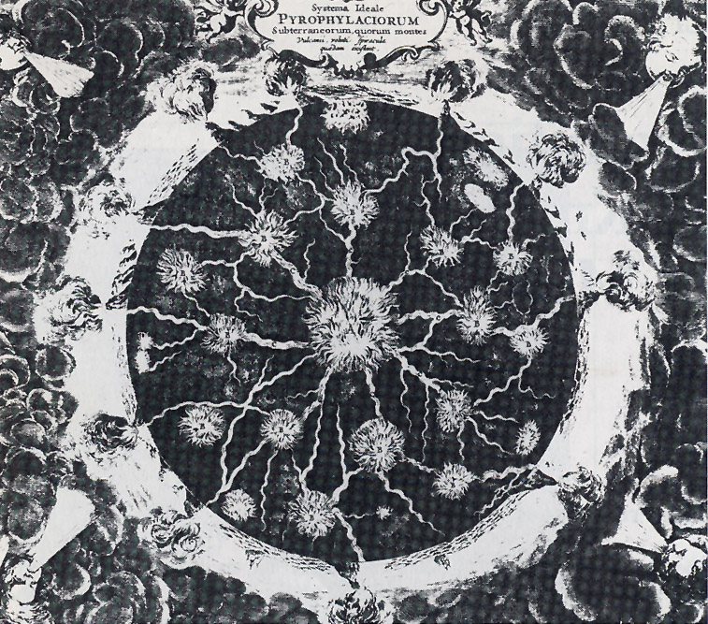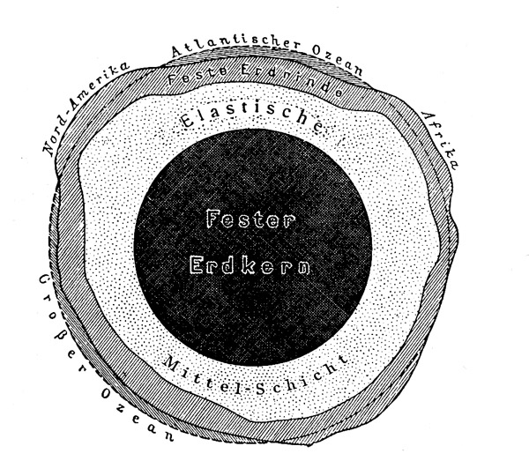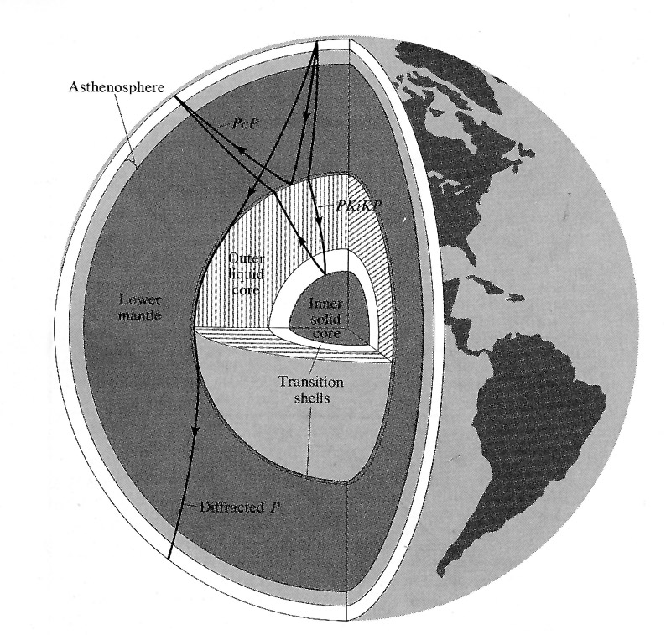
1800 1902 1967

A2.2 Surface structure

●Convection in the mantle causes the lithosphere to move across the surface of the Earth. It is broken into a dozen or so large tectonic plates that move as rigid blocks with most deformation occurring along plate boundaries.

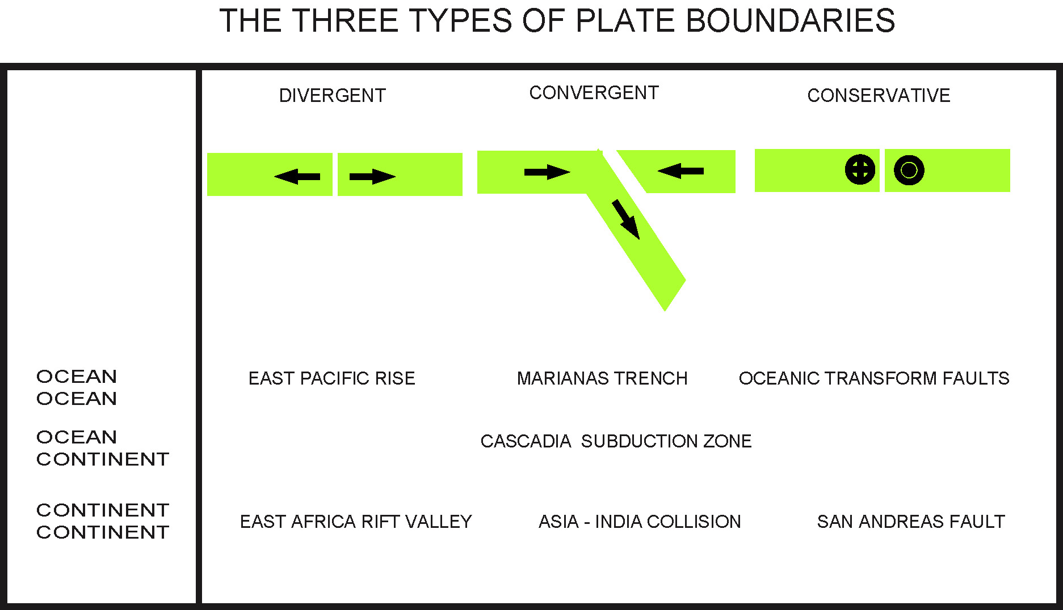

●Three types of plate boundary: convergent, divergent, conservative

●Oceanic crust is denser than continental crust, and can be subducted back into the mantle. No oceanic crust older than 200 million years is found on Earth.

●Less dense continental crust is resistant to subduction and shows a continuum of ages back to more than 4 billion years (oldest known rocks are the Acasta gneisses in the Northwest Territories)

●Detailed elevation maps show these boundaries very clearly, as do maps showing the global distribution of earthquakes and volcanoes.

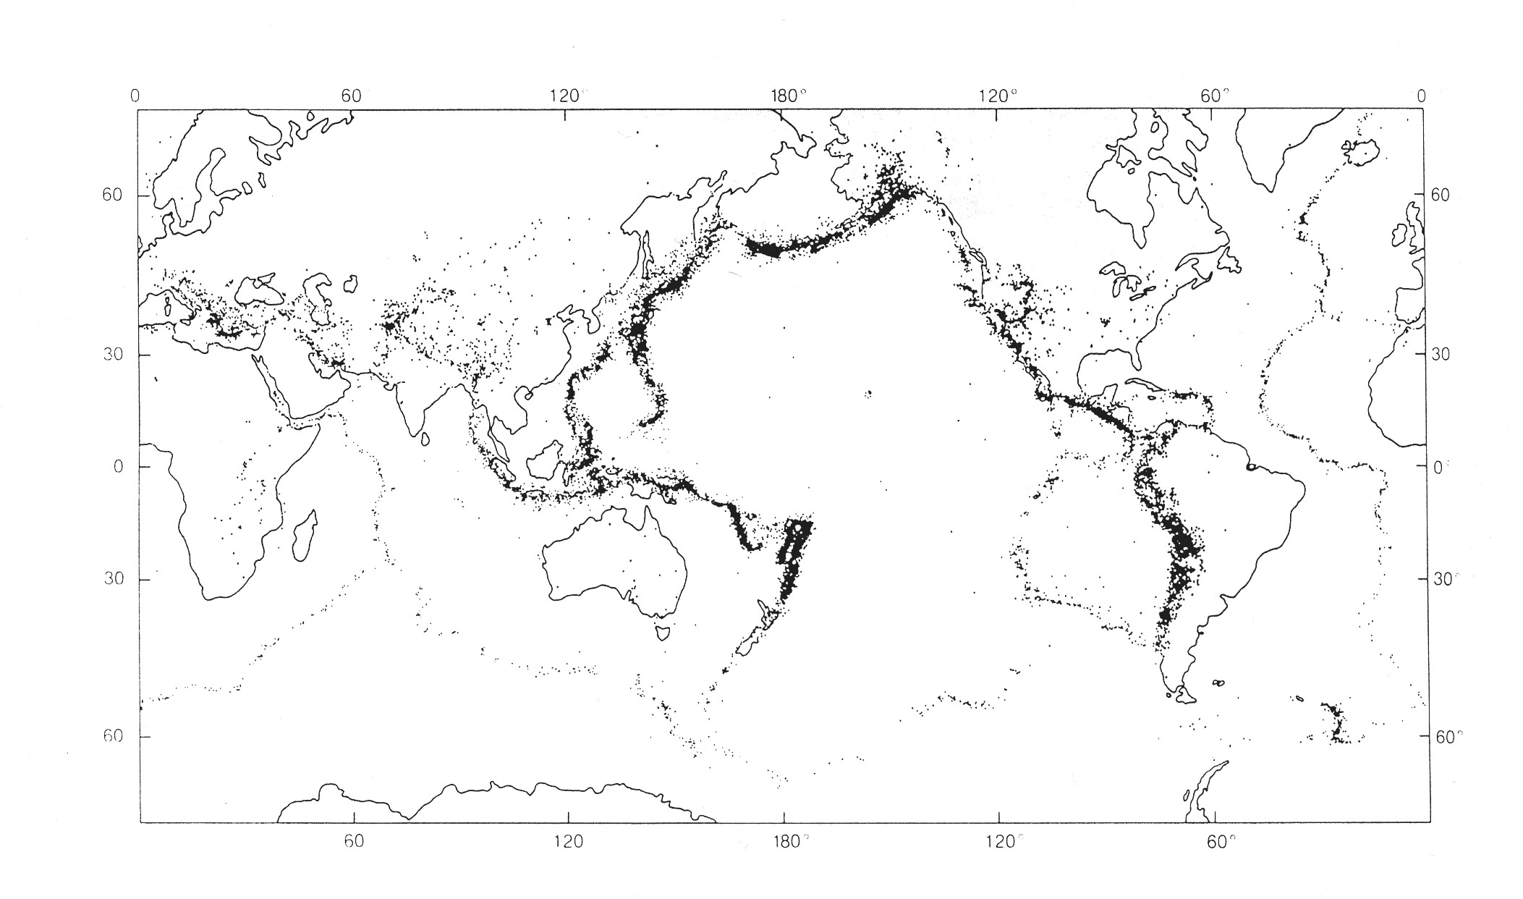

Global seismicity 1961-7 (above) shows that most earthquakes occur in narrow belts. These are now known to be the boundaries between tectonic plates. After major earthquakes, the direction of plate movement can be seen in the offset of previously straight structures.

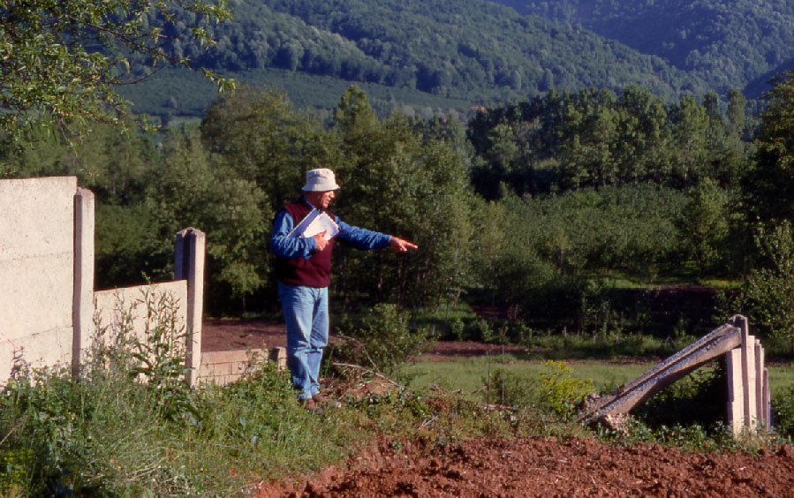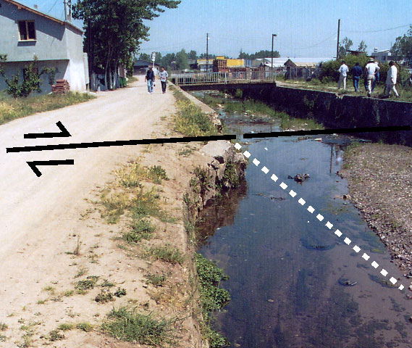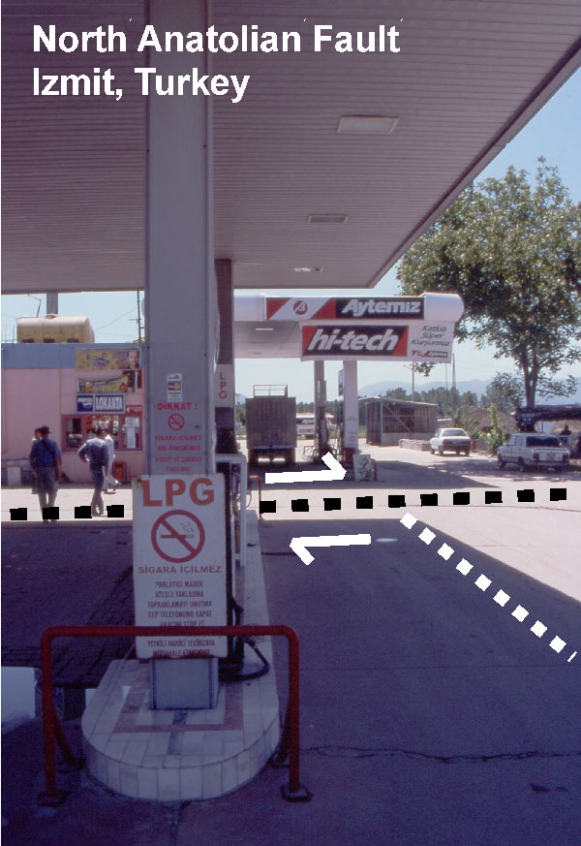
Offset of North Anatolian Fault in Western Turkey after the 1999 Izmit and Duzce Earthquakes (both right lateral strike-slip events)

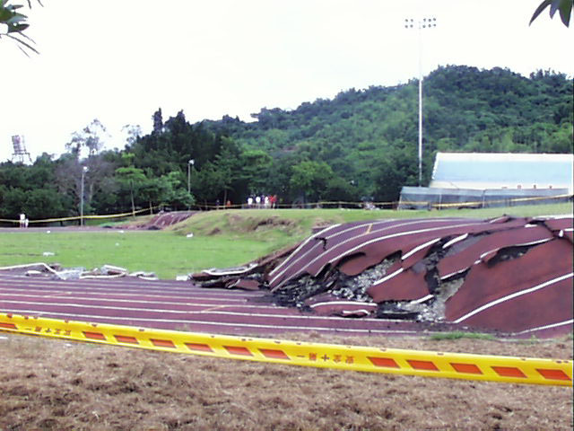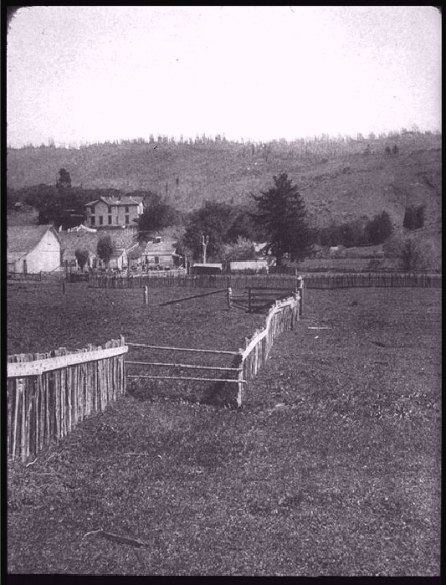
Thrust fault, Taiwan 1999 San Andreas Fault, 1906

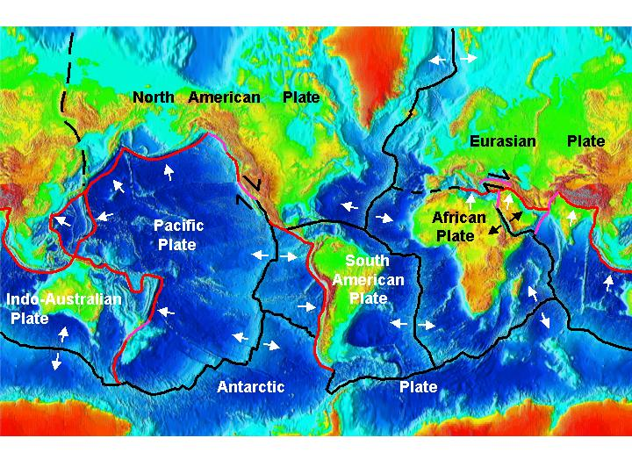
Divergent Convergent Conservative

A3: Overview of exploration methods

A3.1 Common features of all exploration methods
  - Requires a variation in a physical property of the Earth (density, electrical resistivity, magnetization, seismic velocity)
  - Produces measurable signal at the surface
  - Data modelling (or inversion) converts surface data into a model of what is underground.
  - Interpretation of physical property in terms of geology

A3.2 Active and passive exploration methods

Active exploration methods
Signal generated artificially
e.g. seismic waves from explosion, electric current in DC resistivity

Passive exploration methods
Measure a naturally occurring signal
e.g. spatial variations in the acceleration of gravity, magnetic field strength or direction of the Earth’s field
MJU 2005

