Application Note:

TPS6303x Voltage Regulator for use in Battery-Operated Applications

introduction
When powering a microelectronic circuit from batteries designers must take into account the fact that the battery voltages changes with its state of charge. Lithium Ion batteries typically have a useable voltage range between 4.2V and 3V. Therefore, the output of these batteries cannot be used in most microelectronic applications which require a single, constant voltage to operate. This Application Note describes the use of a Texas Instruments TPS6303x Buck/Boost converter for regulating the input voltage to such circuits. The TPS63030 has an adjustable output voltage of 1.2V – 5.5V, with an input range of 1.8V – 5.5V, while the TPS63031 has a fixed output voltage of 3.3V. Gerber files for the design are provided, along with advice for programming the output voltage on the TPS63030.

Design
The design of the board is based to be broken out onto a 2.54mm spaced breadboard. The headers are spaced 20.32mm apart so that it will fit on the board for prototyping ease. Resistors and capacitor packages are 1206 (imperial) so it is easy for the user to solder them to the board.
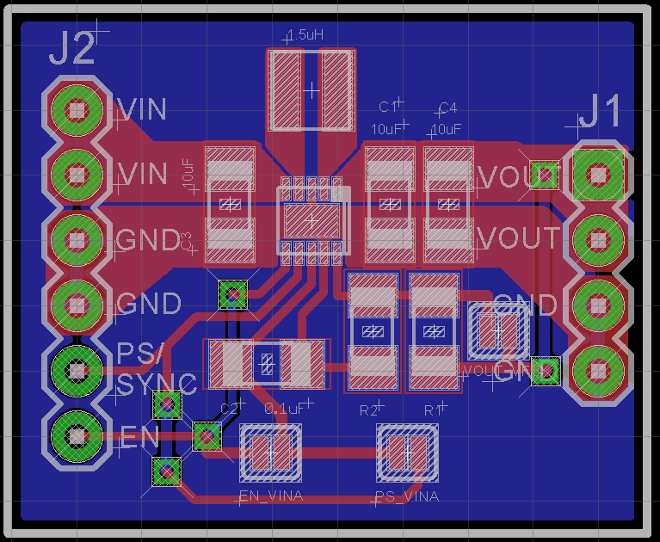
Figure 1. Board Layout of TPS63030 Voltage Regulator
The positive voltage from your battery should be connected to VIN on the input side, with the negative connected to GND. Voltage to the application circuit is output from the VOUT pin on the output side. Be sure to connect the application ground to the output GND, and the batter negative terminal to the input GND for best operation.

Schematic

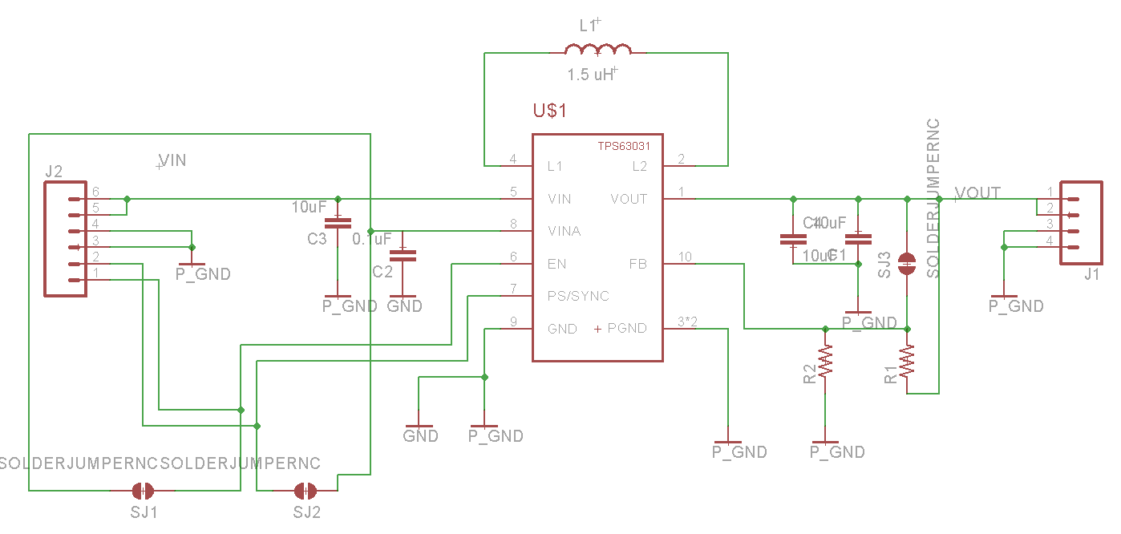
Figure 2. Schematic diagram of the Voltage Regulator

Configuration

Selecting the TPS63030 or TPS63031
The breakout board is compatible with either the TPS63030 or TPS63031 voltage regulators. The TPS63030 provides an adjustable output voltage between 1.2V and 5.5V that can be configured as per Section 3.2. the TPS63031 has a fixed output voltage of 3.3V.

Output Voltage Configuration
The TPS63030 has a programmable output voltage configured by a voltage divider on the input to the FB pin. Using the provided generated Gerber files the voltage divider can be configured by choosing values for R1 and R2 as follows:
$$R_{1}=R_{2}*(\frac{V_{out}}{V_{FB}}-1)$$
Where
$$V_{FB}=500mV$$
$$R_{2}=200kΩ$$
$$V_{out}=Your desired output$$

Note that if you are using TPS63031 R1 and R2 should not be populated on the board.

Solder Jumper Configuration
The breakout board has three solder jumpers to configure its output (see figure 1).

Enable Input
SJ1 configures the EN (Enable) pin. If you would like the device to be always enabled short this solder jumper. Otherwise you will need to manually enable the device by holding the EN pin on the input HIGH to enable the device, or LOW to disable it.

Power Save/Sync Input
SJ2 configures the PS/SYNC (Power Save/Sync) pin. For detailed information on the operation of this input please see the TPS6303x Datasheet. For default operation short this solder jumper.

Configuration for TPS63031
SJ3 is to be used only with TPS63031 devices which have a fixed output. As mentioned above when using the fixed output version R1 and R2 should be unpopulated, with SJ3 shorted.

Component Selection
The below table provides the Digikey Part Numbers for the recommended components for both the TPS63030 and TPS63031.
Component | TPS63030 Adjustable Output | TPS63031 Fixed Output
TPS63030 Adjustable Output | 296-23903-1-ND | N/A
TPS63031 Fixed Output | N/A | 296-23904-1-ND
C1, C3, C4: 10uF 1206 Capacitor | 587-1342-1-ND | 587-1342-1-ND
C2: 0.1uF 1206 Capacitor | 732-8086-1-ND | 732-8086-1-ND
R1: 1206 Resistor | See Section 3.2 | N/A
R2: 1206 200k Resistor | RMCF1206FT200KCT-ND | N/A
L1: 1.5uH Inductor | 490-9576-1-ND | 490-9576-1-ND

Printed Circuit Boards and Solder Stencils
Gerber files are provided that can be given directly to a printed circuit board manufacturer. The gerbers are in RS274X format. The .GTP layer can be used to create a solder stencil.
Gerber File Extension | Description
.TXT | Drills
.GML | Slots/Drill Holes
.GBP | Solder Paste Bottom
.GTP | Solder Paste Top
.GBS | Solder Mask Bottom
.GTS | Solder Mask Top
.GBO | Silkscreen Bottom
.GTO | Silkscreen Top
.GBL | Bottom Copper
.GTL | Top Copper

