**Notes for video 9.1.:** <http://tinyurl.com/rr480/video/cor-reg>

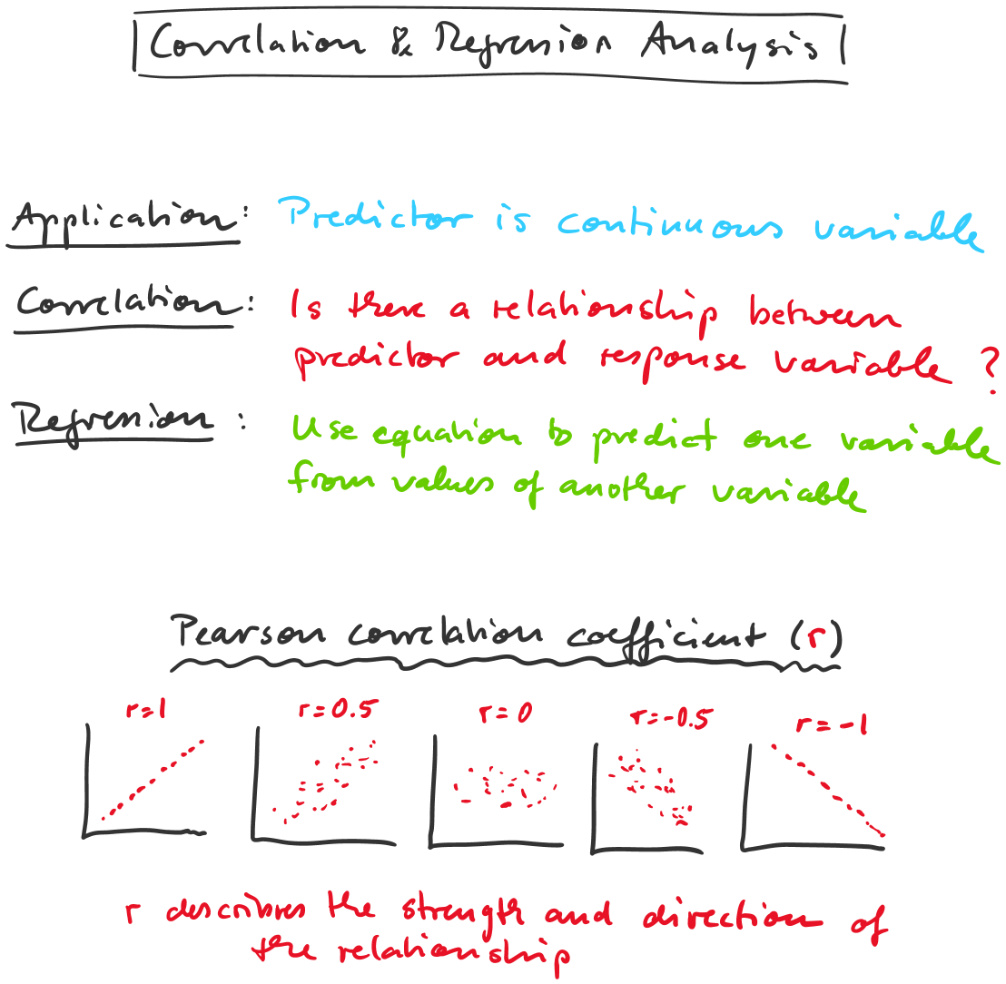

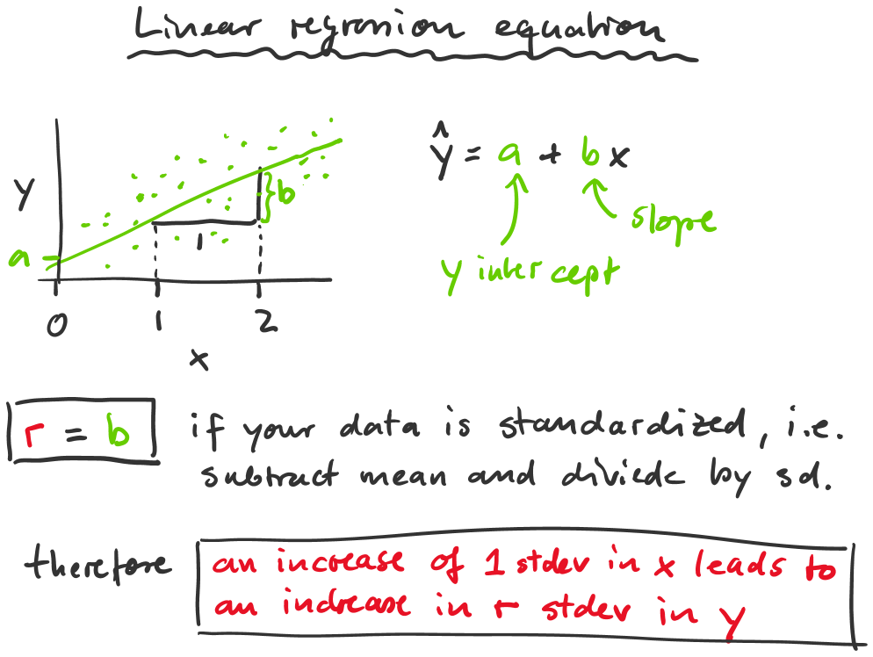

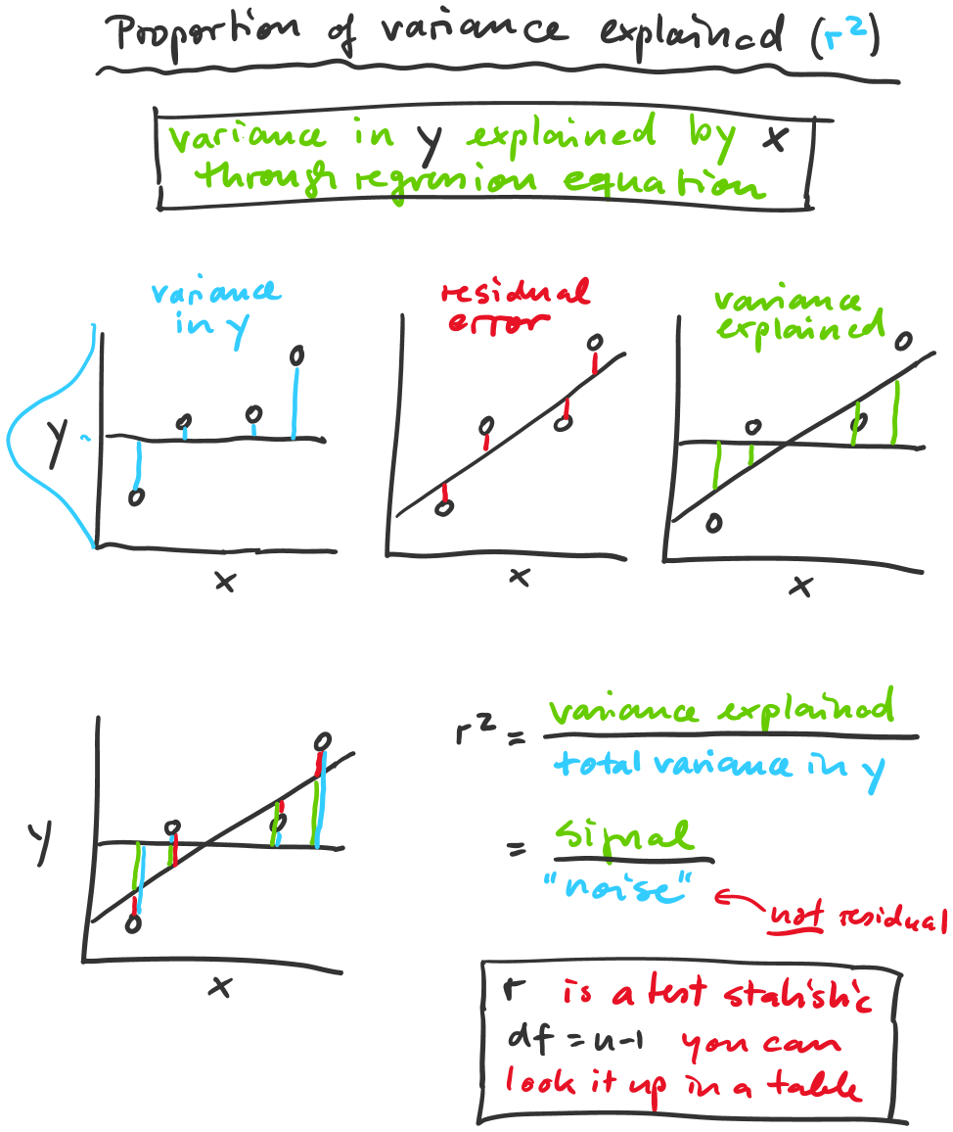

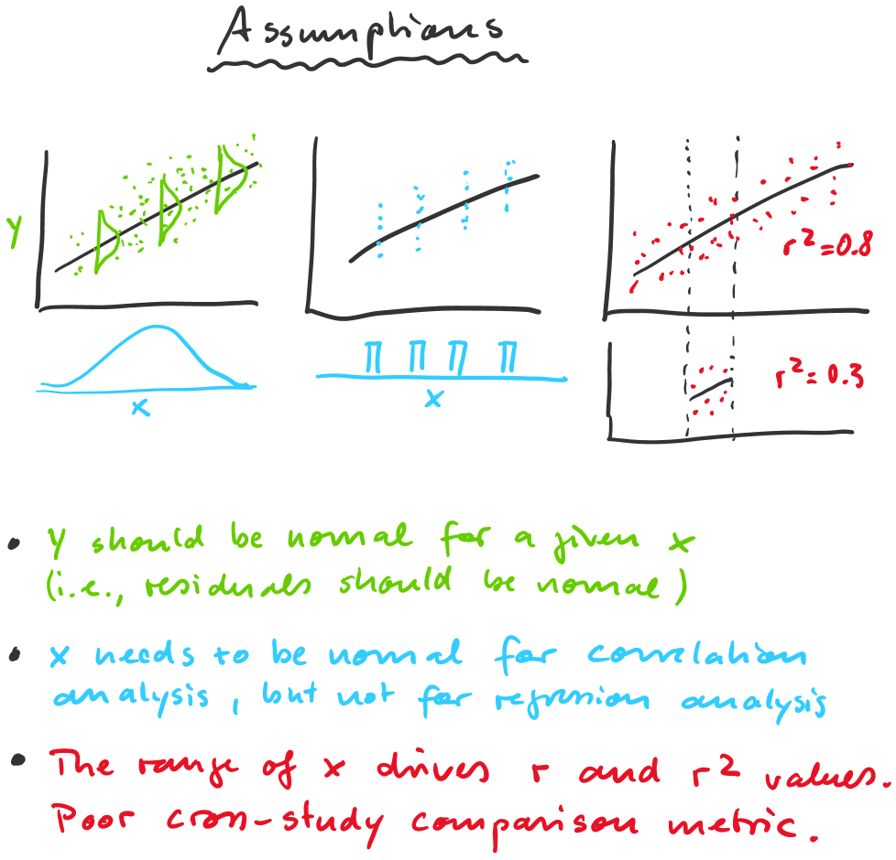

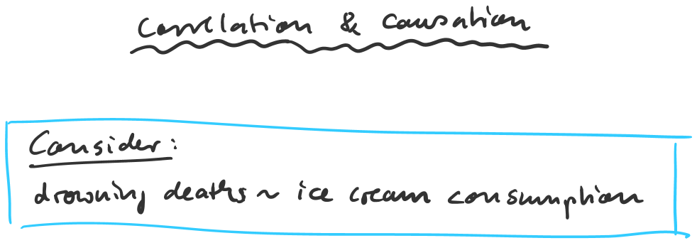



|  |  |  |  |
| --- | --- | --- | --- |
|  |  |  |  |
|  |  |  | C:\Users\ahamann\AppData\Local\Temp\msohtmlclip1\02\clip_image002.png |
|  | C:\Users\ahamann\AppData\Local\Temp\msohtmlclip1\02\clip_image003.png |  |
|  |  |  |

|  |  |  |  |
| --- | --- | --- | --- |
|  |  |  |  |
|  |  |  | Sale of Ice Cream  Weight (avg. per capita)  $100  $50  $25  Dec  Jan  Feb  March April May June July Aug  Time  +5 lbs.  -5 lbs.  Sep Oct  Nov |
|  | C:\Users\ahamann\AppData\Local\Temp\msohtmlclip1\02\clip_image005.png |  |
|  |  |  |

