Notes for video 8.3.: http://tinyurl.com/rr480/video/assumptions

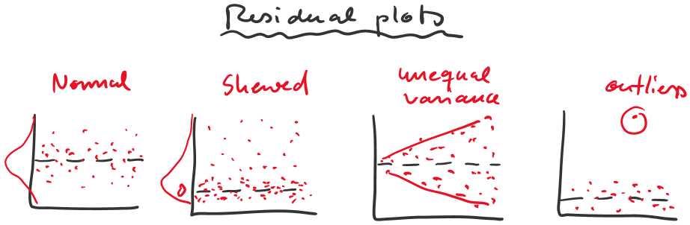

out1 = lm(YIELD ~ VARIETY + FARM)
plot(residual(out1) ~ fitted(out1))

