**Notes for video 6.2.:** <http://tinyurl.com/rr480/videos/2s-t-test>

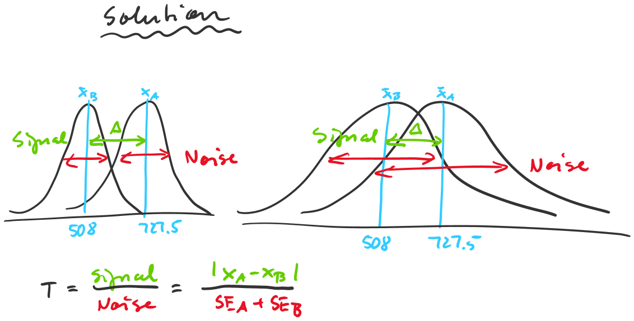

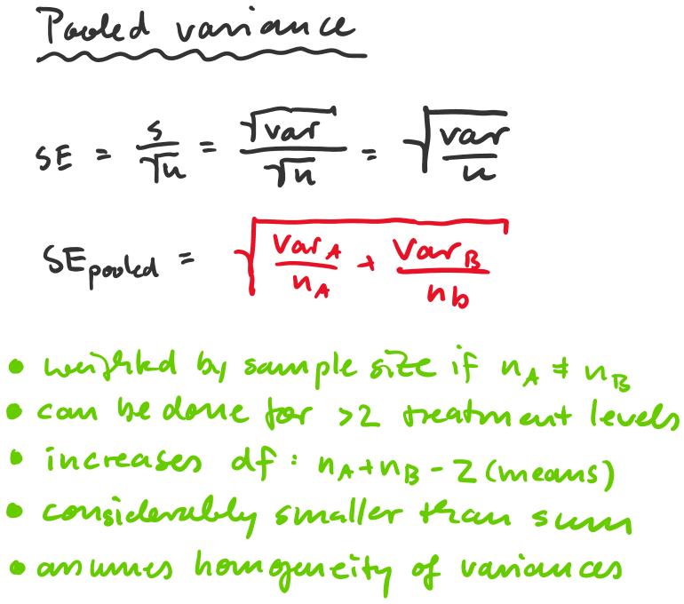



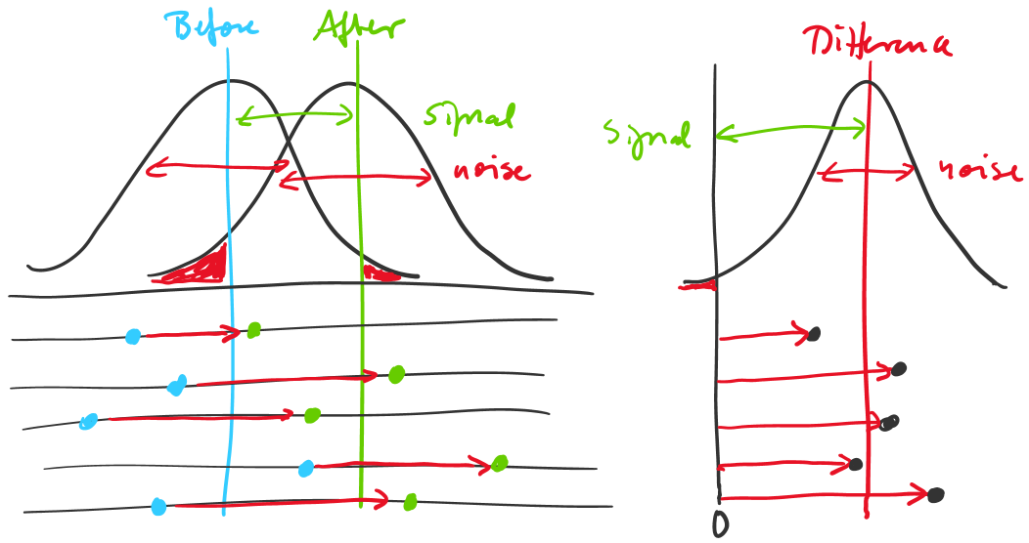

New vocabulary 
• Standard Error (SE): Variation of a statistic 
Statistic is a property Of a sample, e.g. mean, Sd) 
• Confidence Interval (Cl): SE * factor (T-value) 
— to get desired probability 
• T-value:Signal / noise ratio, Difference/ SE 
• P-value: Probability to observe a difference by chance if 
there really is none 

• a-level: pre-set p-value used to calculate confidence 
interval or upper or lower bounds Of a difference. 
• Critical T-value: t-value corresponding to a-level 