Notes for video 2.6.: http://tinyurl.com/rr480/videos/design

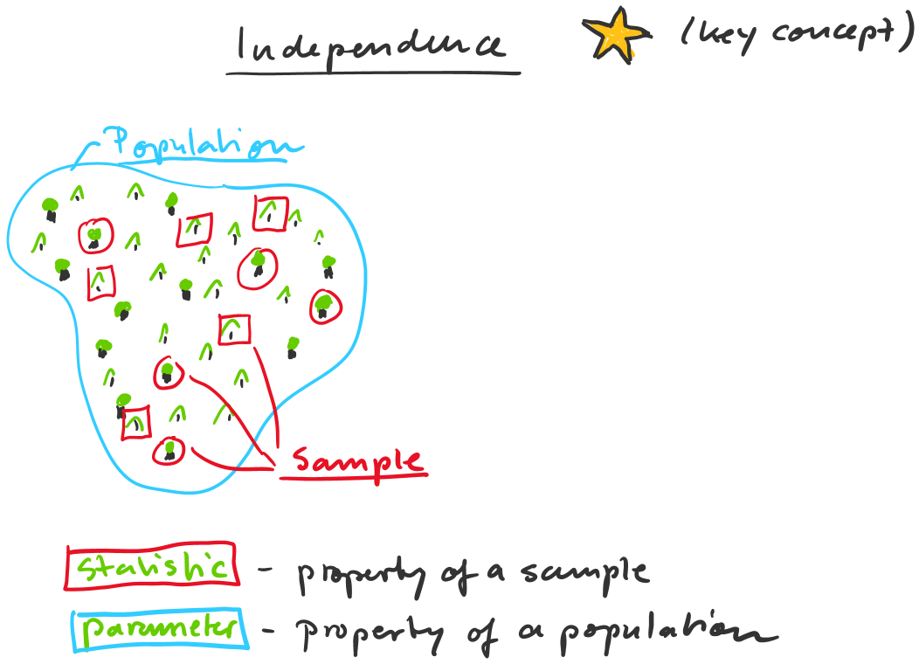

Population: Entirety of objects that you want to make a statement about

We use samples to draw inferences on
populations using statistics

Samples: Subset of objects that you actually study

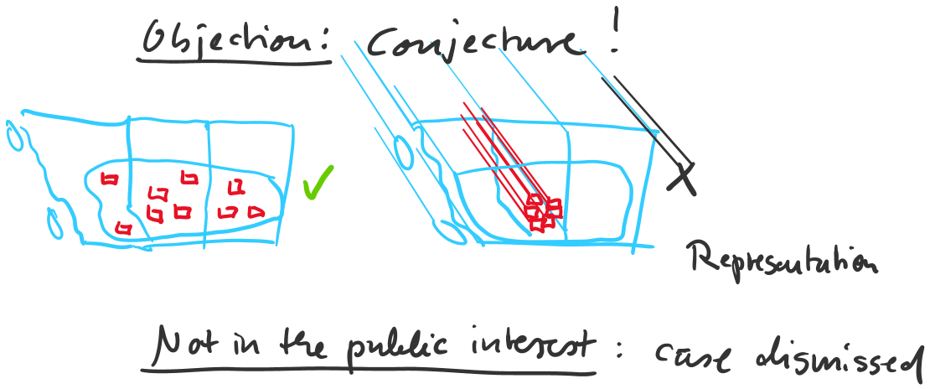

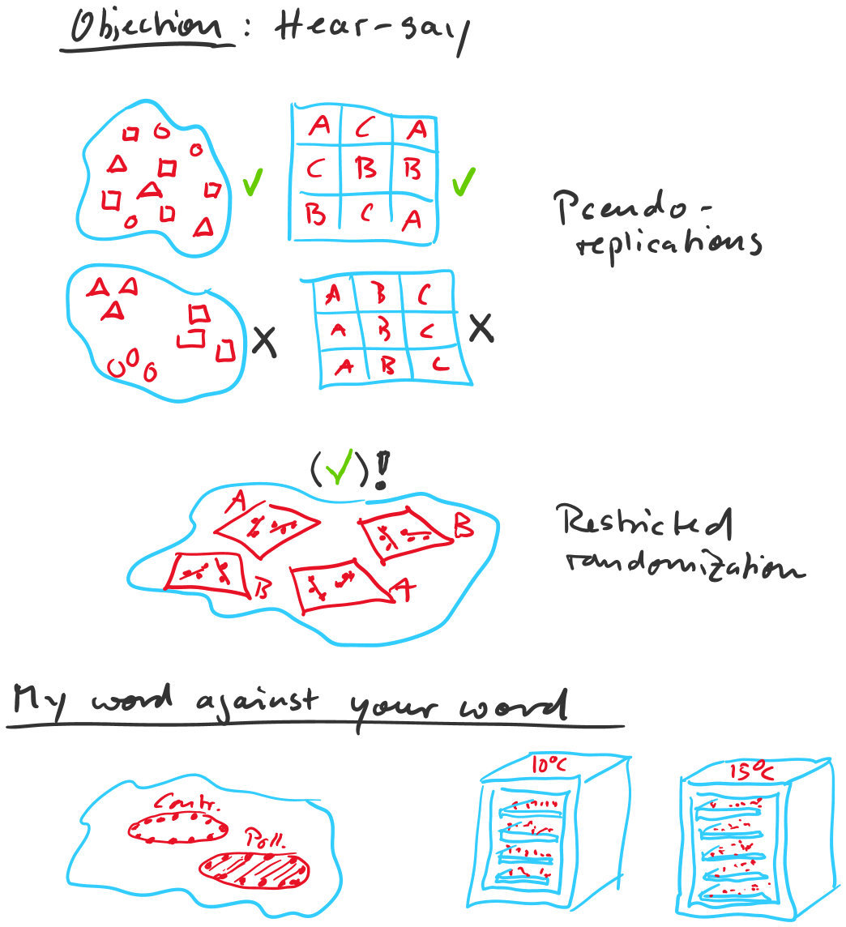
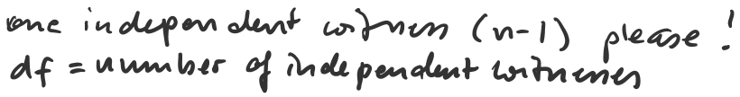

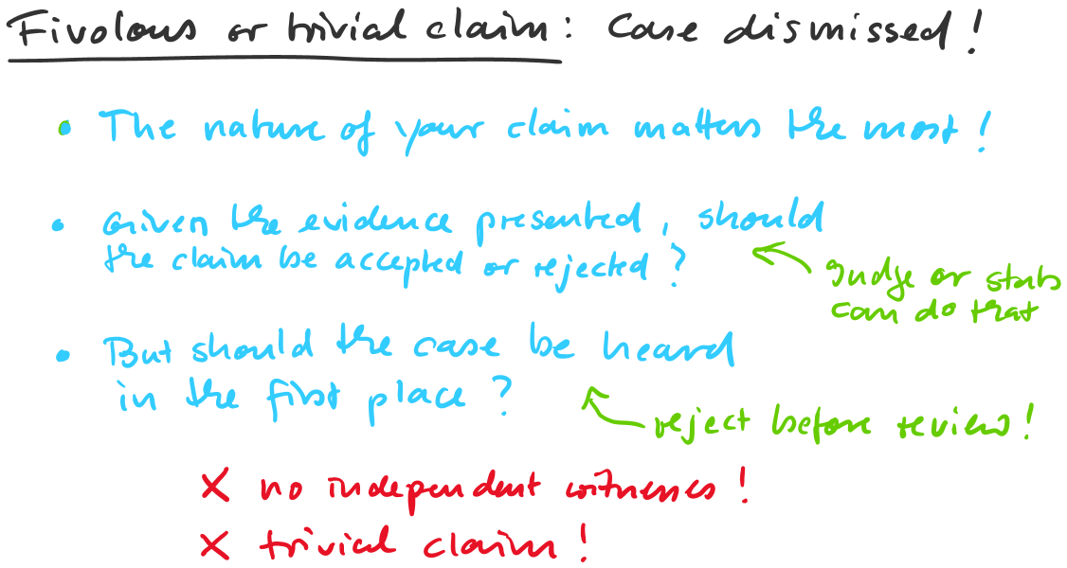

Lodgepole pine grows at least 15% faster than white spruce (p = 0.02)
Lodgepole pine grows at least 15% faster than white spruce (p = 0.2)
Lodgeople pine grows faster than white spruce (p=0.002)

