Notes corresponding to video http://tinyurl.com/mv690/video/permanova

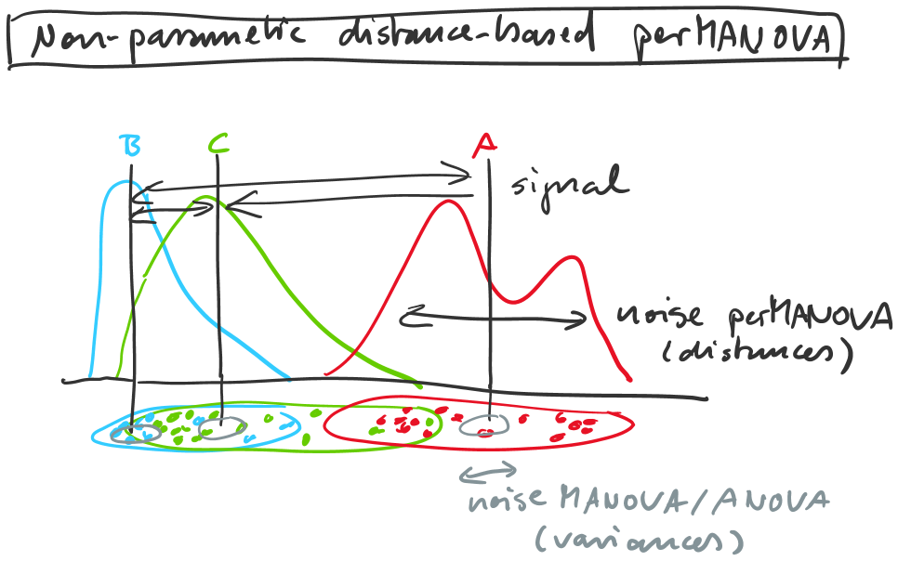

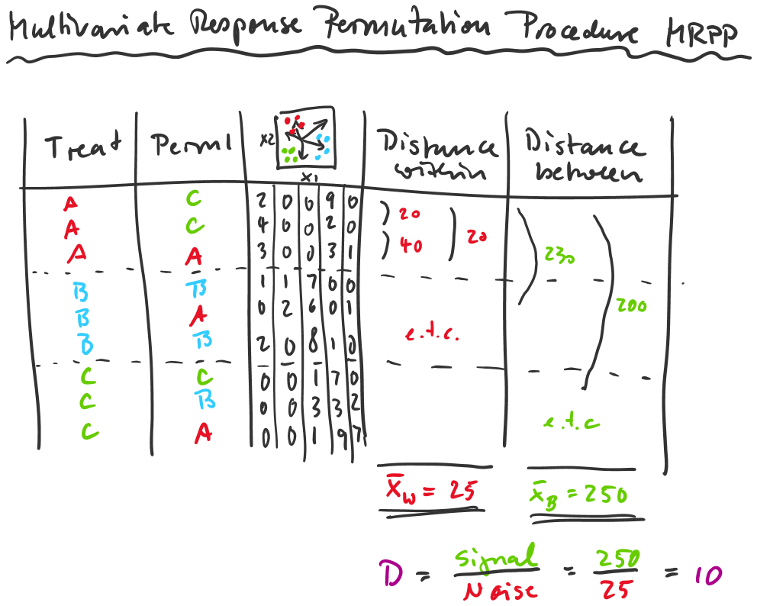

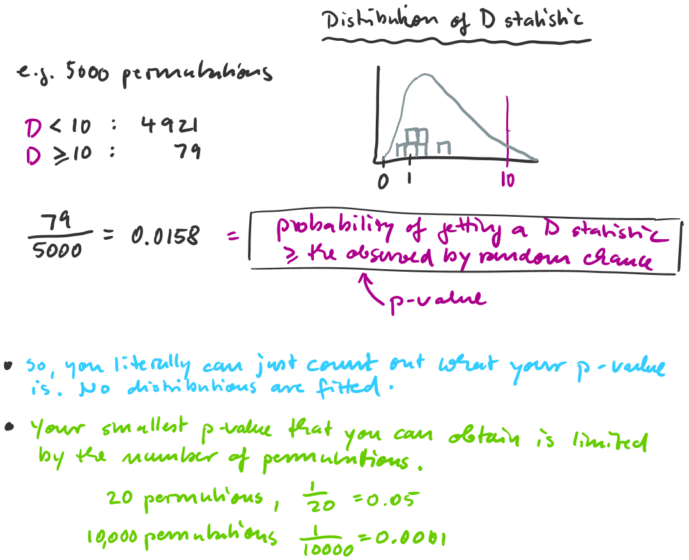

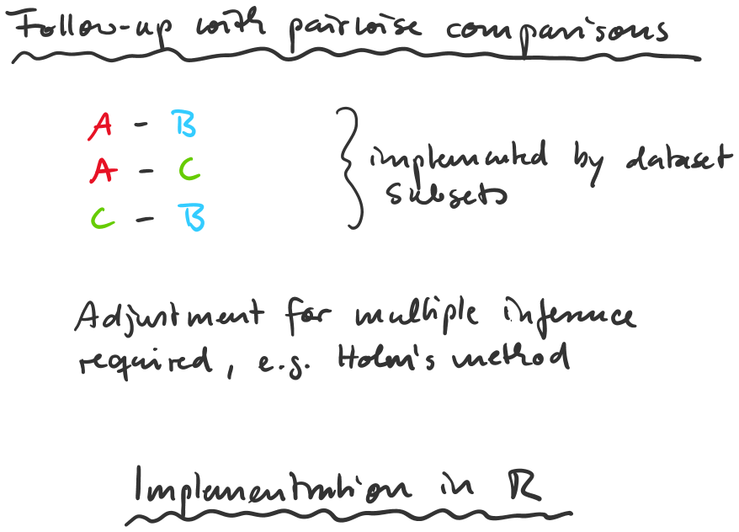

library(vegan)

mrpp(measurements, group=soils, distance="bray")

adonis(measurements ~ soils + fert, distance="bray")
adonis(measurements ~ soils * fert, distance="bray")

bc=bcdist(measurements)
pairwise.perm.manova(bc, soils, p.method="holm")

