Notes corresponding to video http://tinyurl.com/mv690/video/pca2

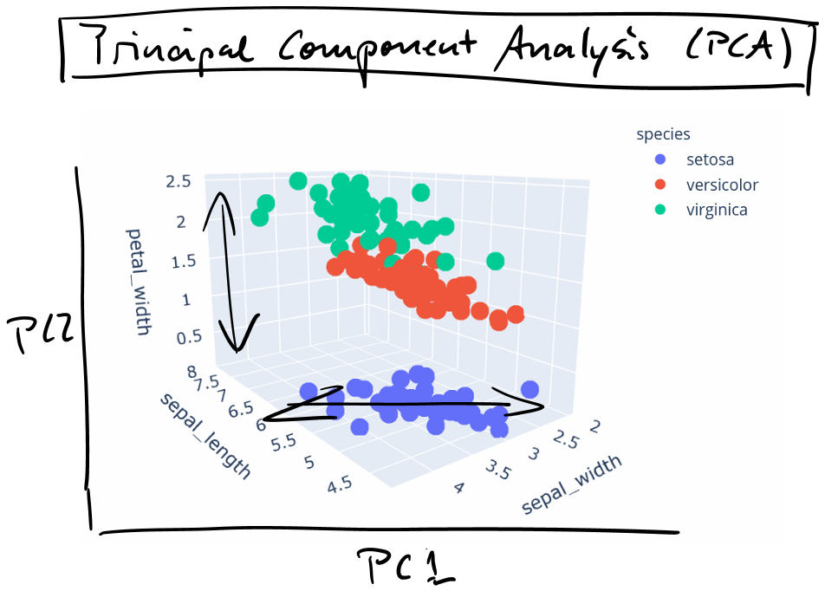

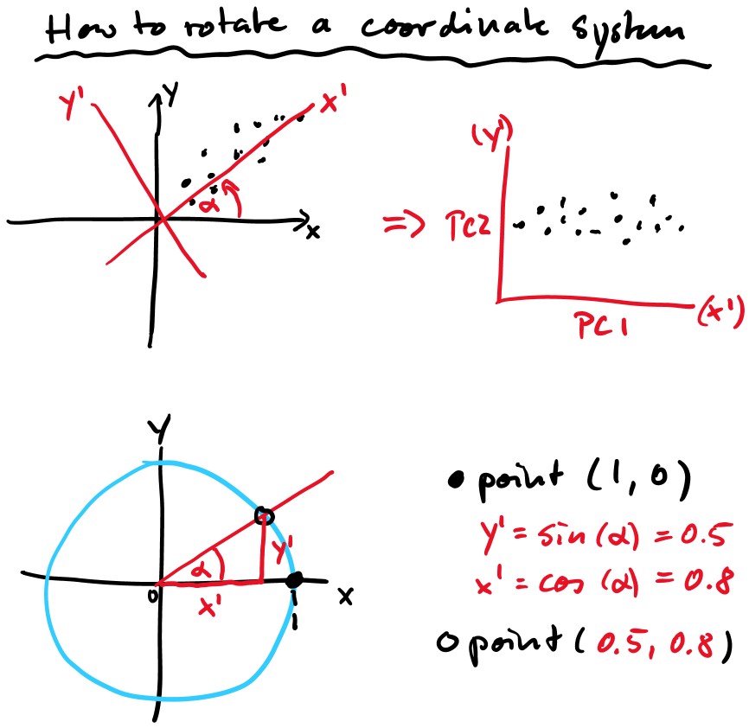

dat2 = as.matrix(dat1) %*% as.matrix(rm)

out1 = princomp(dat1, cor=T)
dat2 = out1$score

summary(out1)
out1$loadings
biplot(out1), choices=c(1,2))

