Notes for video 9.2.: http://tinyurl.com/rr480/video/lm-dummy

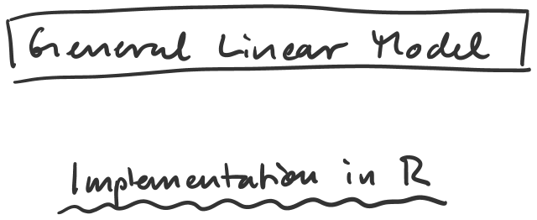

out1 = lm(Y ~ X, data = dat1)
summary(out1)
predict(out1, data = dat2)

out2 = lm(Y ~ X1 + X2)
summary(out2)

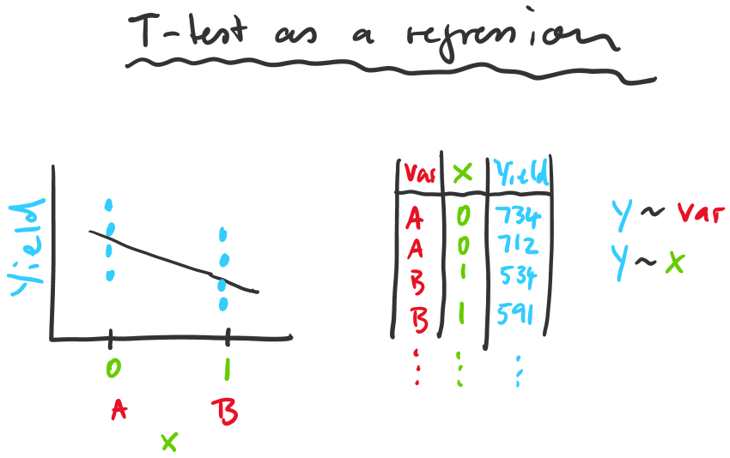

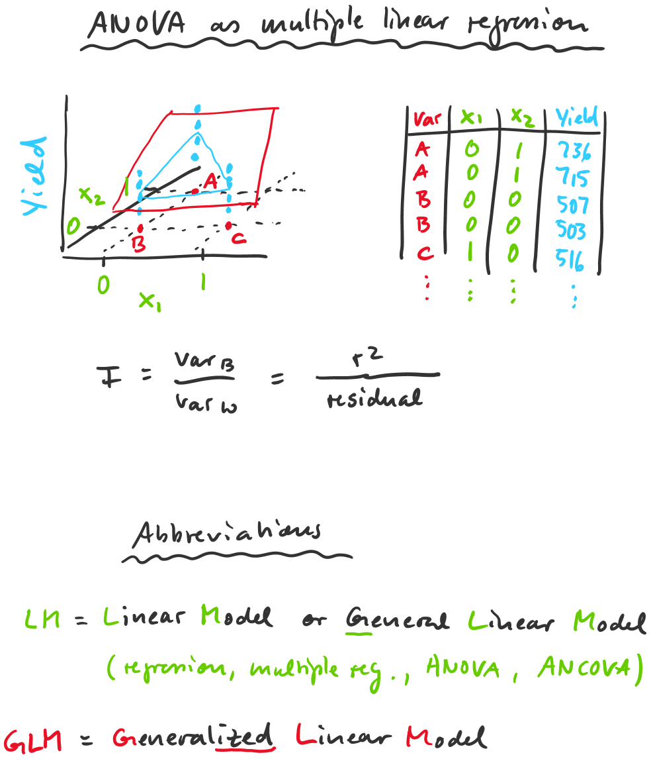
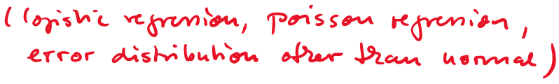
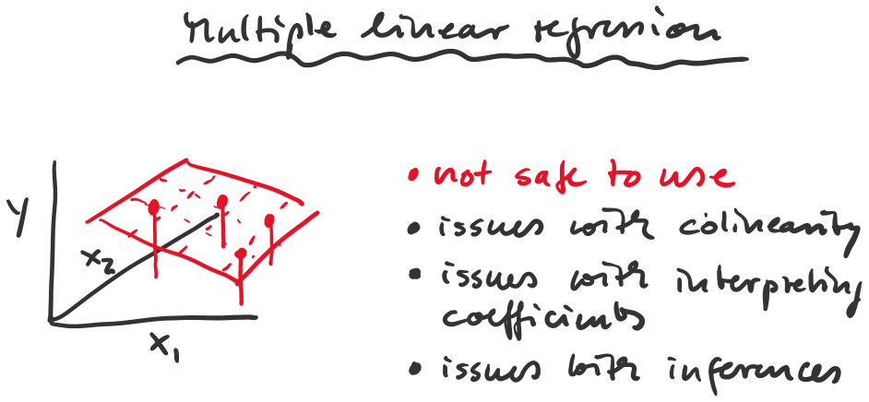

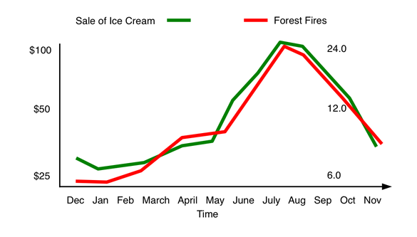
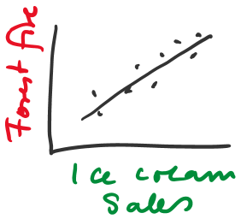

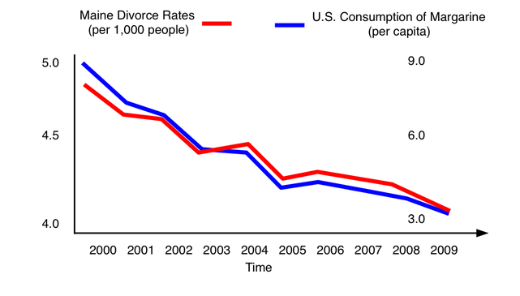
p.adjust(c(0.003,0.067,0.021,0.011), n=4, method="holm")

Rice, W.R. 1989. Analyzing tables of statistical tests. Evolution 43: 223-225.
http://tinyurl.com/rr480/reading/rice1989

