Notes for video 4.2.: http://tinyurl.com/rr480/videos/se-ci

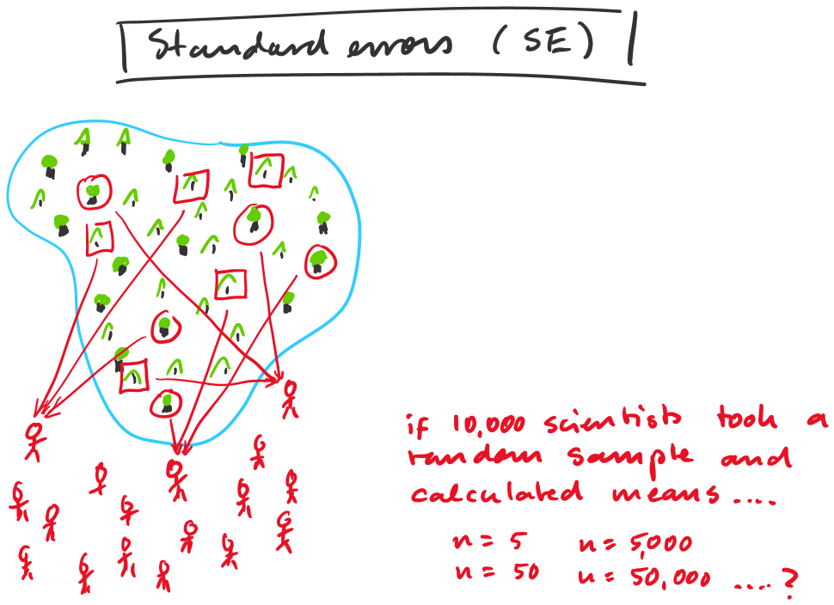

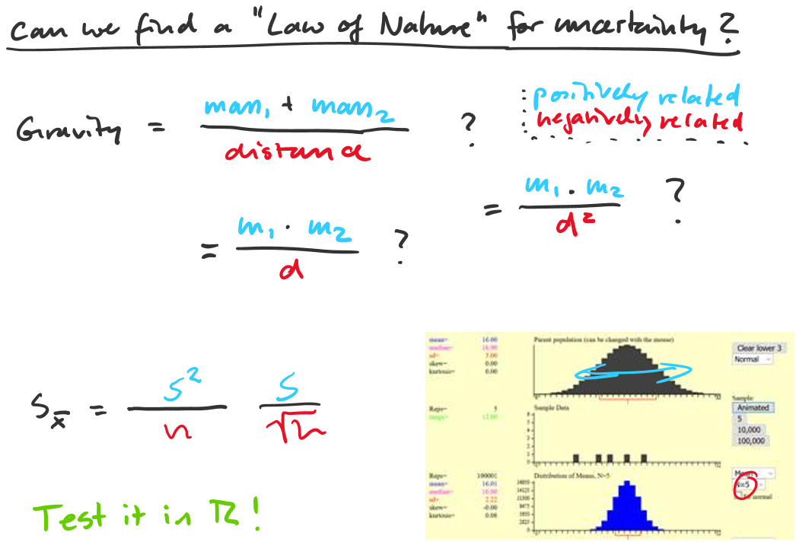
pop1 = rnorm(10000)*3+15
sample1 = pop1[sample(1:10000, 5, replace=F)]

