Notes for video 4.1.: http://tinyurl.com/rr480/video/clt

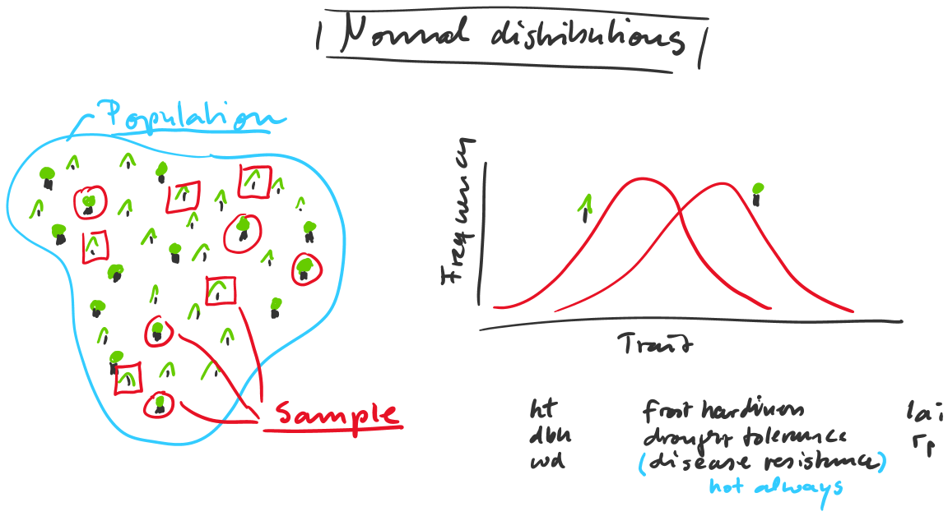

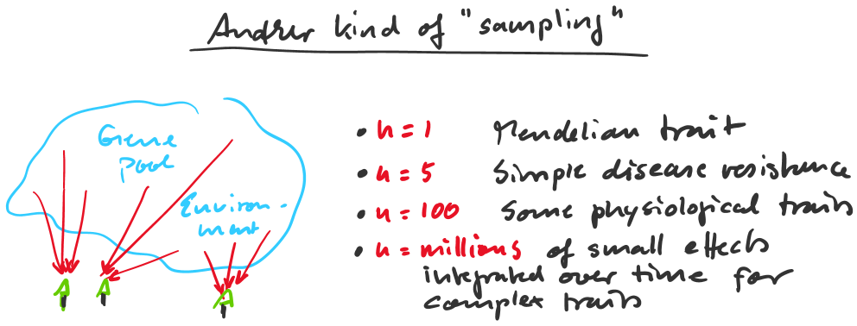

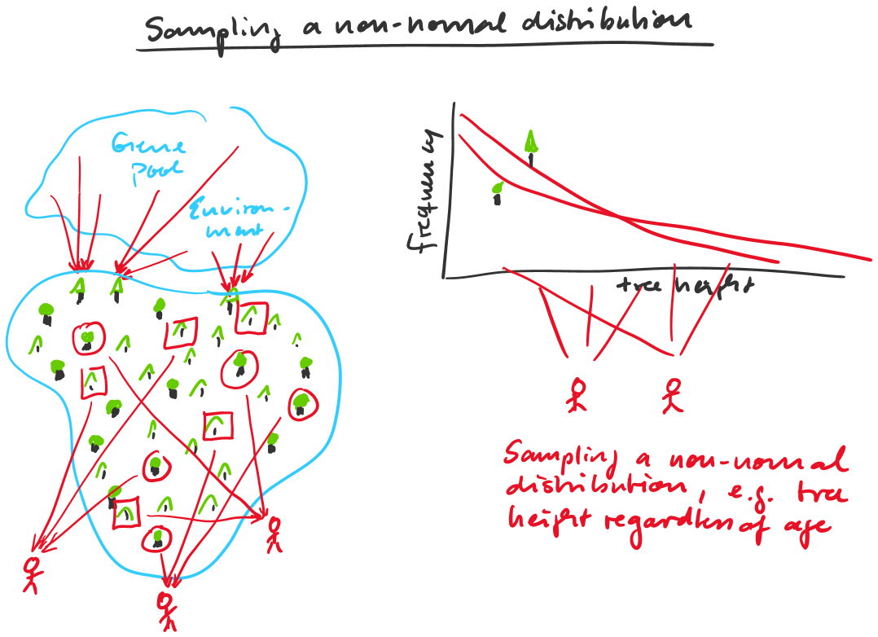

CLT: When independent random variables are added, their sum (or average) tends toward a normal distribution, even if the original variables themselves are not normally distributed

Application 1: Integration of many small effects on individuals leads to normal distributions of their traits in a population

Application 2: Repeated sampling leads to normal distribution of sample statistics, unless the sample size is very small

