Notes for video 3.3.: http://tinyurl.com/rr480/videos/df

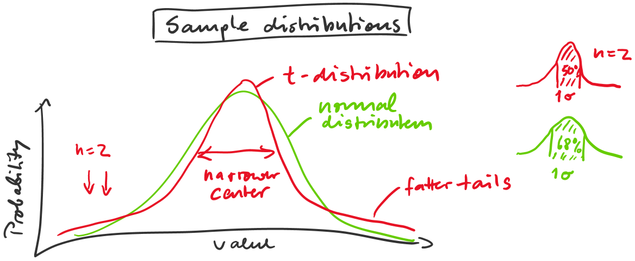

Distribution: probability associated with the value of a variable

(sorry, this file is corrupted, but you can still see the essentials)

