Notes for video: http://tinyurl.com/rr480/video/binomial

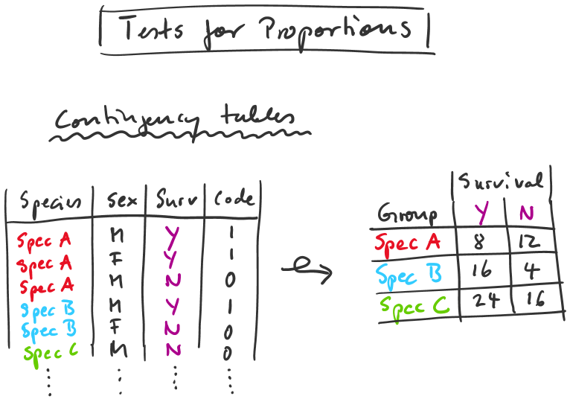

tab1 = table(dat1)
tab1 = table(dat1[,c(1,3)])
tab1 = table(dat1[,c("Species", "Surv")])

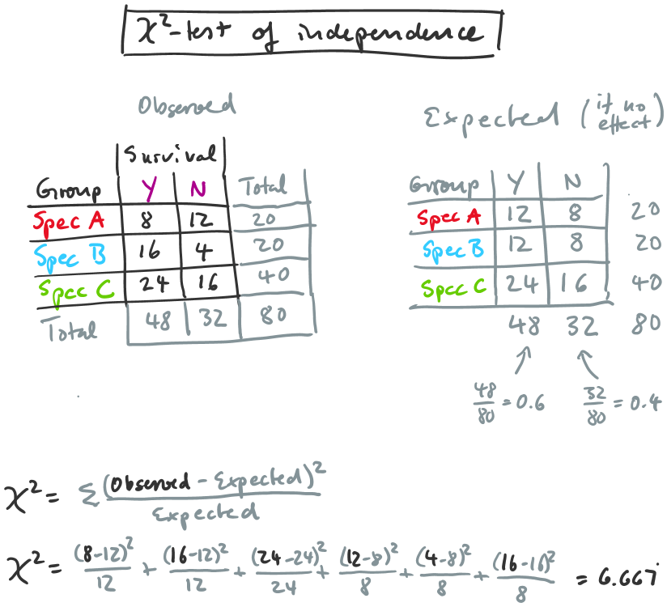

pchisq(6.667,2)

chisq.test(tab1)
prop.test(tab1)

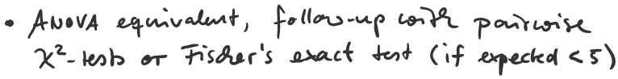
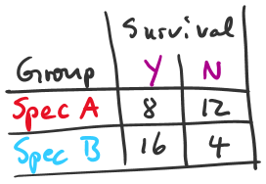
fischer.test(tab2)
chisq.test(tab2)
prop.test(tab2)

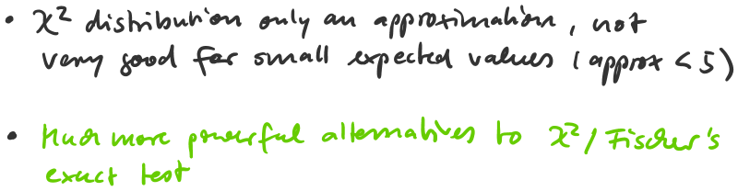

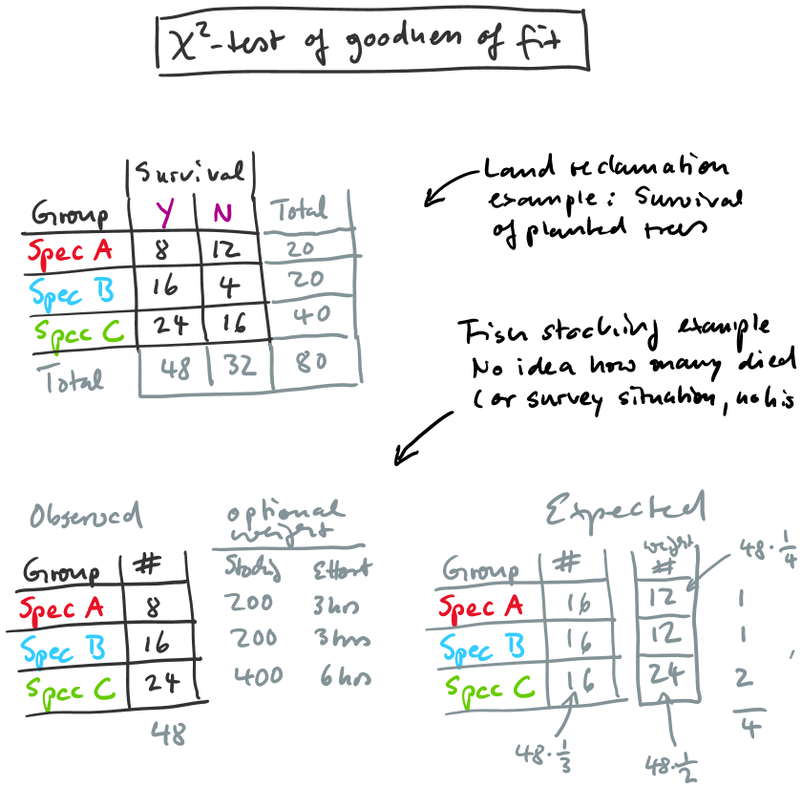

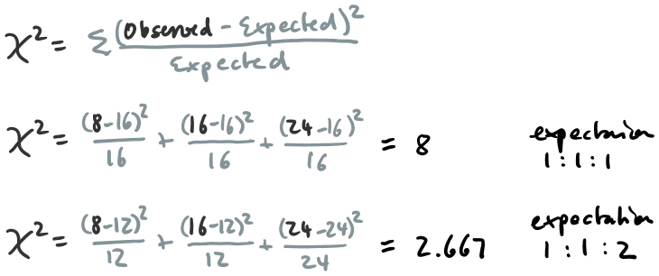

tab3 = c(8,16,24)
chisq.test(tab3)
chisq.test(tab3, p=c(1/4,1/4,1/2))
chisq.test(tab3, p=c(3,3,6), rescale.p=T)

