__________________________________________

ClimateEU v5.00

A program to generate climate normal, annual, seasonal, and monthly climate data for historical and future periods in Africa

Tongli Wang & Andreas Hamann

Feb 19, 2025

Contact:
tongli.wang@ubc.ca (software issues)
andreas.hamann@ualberta.ca (data and usage issues)

__________________________________________

About this program

ClimateEU is a standalone MS Windows® application written in Visual Basic 6.0. It extracts and downscales climate data from built-in climate grids to estimate 75 climate variables for historical time periods (months, years, decades, and 30-year normal periods from 1901 to 2020), and for the future periods 2020s (2011-2040), 2050s (2041-2070) and 2080s (2071-2100), based on CMIP6 multi-model projections.

Climate variables generated by the software include monthly base variables (mean minimum, maximum and average temperature as well as precipitation). In addition, economically or biologically relevant variables such as growing and chilling degree days, heating and cooling degree days, Hargrave's climate moisture deficit and reference evaporation, and seasonal variables.

The climate grids were developed with a deep neural network that uses geographic and atmospheric information to model local weather patterns at medium resolution (e.g. see Fig 1).
Subsequently, the ClimateAF software employs lapse-rate based dynamic downscaling to generate gridded data at high resolution, or to provide scale-free point estimates of climate variables for user-provided latitude, longitude and elevation coordinates.

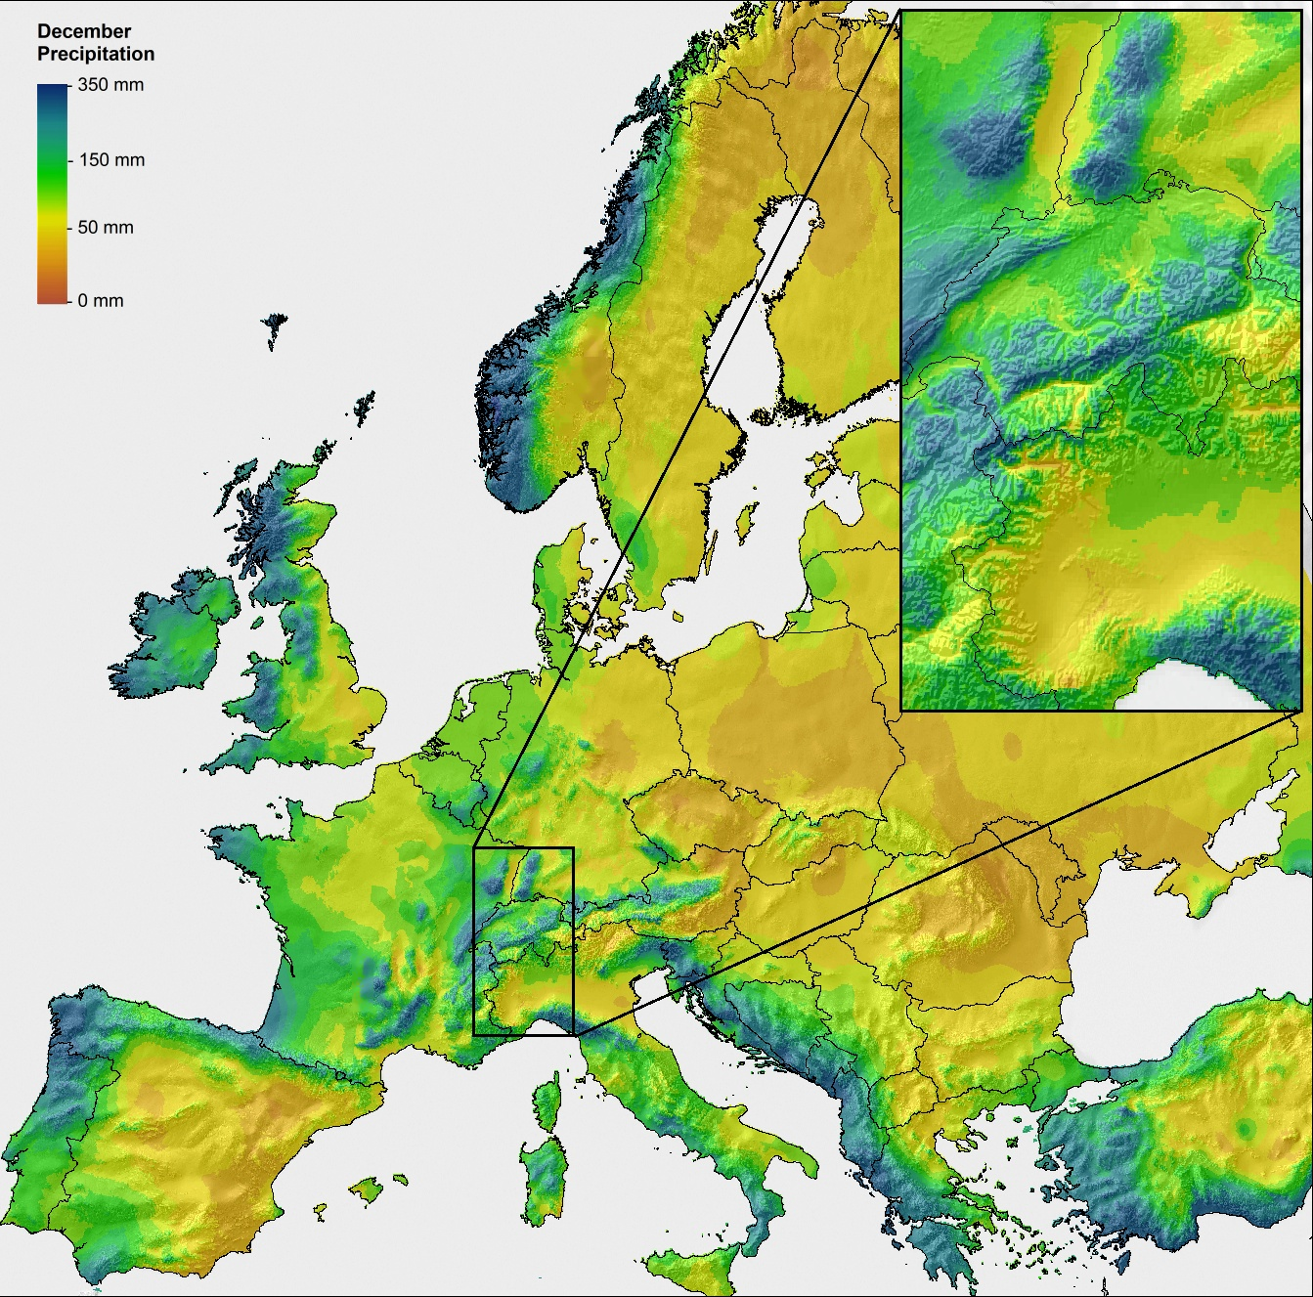
Figure 1. Extent of the ClimateEU data coverage (Lat. 34.26 – 71.24°, Long. -10.74 – 44.24°). The map shows an example for precipitation, with the inset showing precipitation induced by orographic lift on the windward side, and rain shadows on the leeward side of the alps region.

Climate variables predicted

1) Annual variables:
Directly calculated variables:
MAT mean annual temperature (°C),
MWMT mean warmest month temperature (°C),
MCMT mean coldest month temperature (°C),
TD temperature difference between MWMT and MCMT, or continentality (°C),
MAP mean annual precipitation (mm),
MSP mean summer (May to Sept.) precipitation (mm),
AH:M annual heat:moisture index (MAT+10)/(MAP/1000))
SH:M summer heat:moisture index ((MWMT)/(MSP/1000))

Derived variables:
DD<0 degree-days below 0°C, chilling degree-days
DD>5 degree-days above 5°C, growing degree-days
DD<18 degree-days below 18°C, heating degree-days
DD>18 degree-days above 18°C, cooling degree-days
NFFD the number of frost-free days
FFP frost-free period
bFFP the Julian date on which FFP begins
eFFP the Julian date on which FFP ends
PAS precipitation as snow (mm) between August in previous year and July in current year
EMT extreme minimum temperature over 30 years
Eref Hargreaves reference evaporation
CMD Hargreaves climatic moisture deficit
2) Seasonal variables:
TAV_wt winter (Dec.(prev. yr) - Feb.) mean temperature (°C)
TAV_sp spring (Mar. - May) mean temperature (°C)
TAV_sm summer (Jun. - Aug.) mean temperature (°C)
TAV_at autumn (Sep. - Nov.) mean temperature (°C)

TMAX_wt winter mean maximum temperature (°C)
TMAX_sp spring mean maximum temperature (°C)
TMAX_sm summer mean maximum temperature (°C)
TMAX_at autumn mean maximum temperature (°C)

TMIN_wt winter mean minimum temperature (°C)
TMIN_sp spring mean minimum temperature (°C)
TMIN_sm summer mean minimum temperature (°C)
TMIN_at autumn mean minimum temperature (°C)

PPT_wt winter precipitation (mm)
PPT_sp spring precipitation (mm)
PPT_sm summer precipitation (mm)
PPT_at autumn precipitation (mm)

3) Monthly variables
Tave01 – Tave12 January - December mean temperatures (°C)
Tmax01 – Tmax12 January - December maximum mean temperatures (°C)
Tmin01 – Tmin12 January - December minimum mean temperatures (°C)
PPT01 – PPT12 January - December precipitation (mm)

How to install

No installation is required. Simply copy all two files (“ClimateEU_v5.00.exe” and “Help.rtf”) and the three subfolders (“Prismdat”, “Perioddat”, GCMdat”) to the same location on your hard disk and double click the file ClimateEU_v5.00.exe”, or directly run from CD (Note that the program will run much faster from a hard drive), but not on network drives.

In case it does not run on your computer, you may need to download the library file and install it.
http://www.genetics.forestry.ubc.ca/cfcg/res_climate-models/libraryfiles.exe

Using the ClimateEU program

1) Use the program interactively

- Latitude and longitude can be entered in either decimal degrees (e.g. Lat: 51.542, Long: 129.333) or degree, minute and second (e.g., 51°30’15”N, 129°15’30’W). For decimal degrees note that positive or negative values indicate east or west. Elevation has to be entered in meters, or empty if no elevation data available. If "Monthly variables", "Seasonal variables" or "All variables" output variables was selected, an additional output sheet appears and annual climate variables are still calculated.

- Output data can be saved as text file and imported to a spreadsheet using space-delimited option.

2) For multi-location process

- Most users will have their sample data information in an Excel spreadsheet or in a text file. To make it possible for the program to read this data it must be prepared in Comma Separated Values (CSV) format, and decimal point must be a period (.) not a comma.

- Create a spreadsheet with the headers “ID1, ID2, lat, long, el” as shown in the example below. ID1 and ID2 can be “Location”, “Region” or whatever. It does not matter what variable names you choose, but the file must have the header row, and the variables must be in exactly the same order as shown below. If you don’t have elevation information or a second ID, you still need a variable header, you should put a period “.” in these columns. If you have more columns in your original file, you must remove them. Merge them back based on your IDs after the software is done with the data processing.

- Also note that longitude values are read in decimal degrees, and western hemisphere longitudes and southern hemisphere latitude values must be negative. If you have your coordinates in degees, minutes (and seconds), you can apply the formual: DD+MM/60 (+SS/3600) to convert to decimal degrees in Excel.

- After the spreadsheet is prepared as shown, save it as “comma delimited text file” by choosing “Save as …” form the file menu, and then specifying (*.csv) from the “Save as type …” drop down menu.

- You can also directly create a comma delimited text file in any text editor such as Notepad. If there is a missing value, you need to enter a “.” between two commas.

- Save this text file with a .csv extension by writing out the full file name with extension in parenthesis when saving, e. g. “test.csv” instead of test.csv or test.

- Now you are ready for processing: Click on to read your spreadsheet and on to specify your output file folder and file. Then, click the button. Climate variable information will be appended as additional columns to your input file. If elevation information is provided the climate variables will be elevation adjusted.

R code to generate custom climate grids

You can also generate your own custom climate grids with this handy R code:

- Create a custom input file from a DEM for your study area

library(terra)
vec1 <- vect("Your_study_area_in_WGS84- EPSG4326.shp")
ras1 <- rast("Your_DEM_in_WGS84- EPSG4326.tif")
ras1 <- crop(ras1, ext(vec1))
ras1 <- mask(ras1, vec1)
plot(ras1)
plot(vec1, add=T)
writeRaster(ras1, "Custom_DEM.asc")

- The next step requires the R library SDMTools. For this, install RTools.exe for your version of R: https://cran.r-project.org/bin/windows/Rtools/. Then run this code:

install.packages("remotes")
remotes::install_github("cran/SDMTools")
- Now, you are good to go to easily create an input file with a few lines of code from your custom DEM created in the previous step:

library(SDMTools)
dat1 <- asc2dataframe("Custom_DEM.asc")
dat1$ID1 <- row.names(dat1)
dat1$ID2 <- 0
names(dat1)[1:3] = c("LAT","LONG","ELEV")
dat1 <- dat1[,c(4:5,1:3)]
head(dat1)
write.csv(dat1, "ClimateAF_input.csv", row.names=F, na="")

- Once the software has processed the input file representing your DEM, you can convert it back into climate grids like this:

dat1 <- read.csv("ClimateAF_output_Normal_1961_1990MSY.csv")
dat1[dat1 == -9999] <- NA
dat1 <- na.omit(dat1)
dat1 <- dat1[,-c(1:2)]
library(SDMTools)
dir.create("ASCII_files")
dataframe2asc(dat1, out="ASCII_files")

- Lastly, you can convert them back to TIFF files (or any other format) if you wish:

library(terra)
dir.create("TIFF_files")
files <- list.files("ASCII_files", pattern="asc")
for (file in files) {
ras1 <- rast(paste0("ASCII_files/", file))
path <- file.path(paste0("TIFF_files/",
tools::file_path_sans_ext(basename(file)), ".tif"))
writeRaster(ras1, path, overwrite=T)
}

References

We are working on a short publication that explains new methods and datasets underlying ClimateEU v5. Meanwhile you can cite as follows: "Climate data has been generated with the ClimateEU v5.00 softwarepackage, available at http://tinyurl.com/ClimateEU, based on methodology similar to Mahoney et al. (2022) and Marchi et al. (2020)."

Mahoney, C.R., Wang, T., Hamann, A., Cannon, A.J. 2022. A CMIP6 ensemble for downscaled monthly climate normals over North America. International Journal of Climatology 42: 5871-5891.

Marchi, M., Castellanos-Acuna, D., Hamann, A., Wang, T., Ray, D. Menzel, A. 2020. ClimateEU, scale-free climate normals, historical time series, and future projections for Europe. Scientific Data 7: 428. doi: 10.1038/s41597-020-00763-0

Acknowledgements

This research has, in part, been sponsored by the Alexander von Humboldt foundation and an NSERC Discovery Grant.

